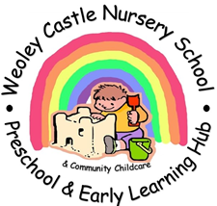
WEOLEY CASTLE NURSERY SCHOOL
COMMUNITY CHILDCARE & EARLY LEARNING HUB
In 2009 we opened our Children’s Centre Day Care – Little Builders- in this building. As the local needs for childcare changed we adapted and developed a 2year-old programme here and offered a range of family support initiatives and groups. By 2014 we were a DfE Community Childcare and Early Learning Hub offering a range of services such as blended childcare, places for 2’s, SEND support for children and families and professional development and training for practitioners. We also ran our Sure Start Children’s Centre services from here. In 2018 sadly, BCC decommissioned all of these centres, city wide, and our health partners took over the running of a new type of children’s centre. We ran our Castle Approach to support a local offer of opportunities for children and families with concerns about their children’s development from here throughout the whole of the pandemic period working in bubbles and virtual platforms.
We now run our Developing Local Provision services out of the Hub and also provide facilitated space to professional partners such as Health Visitors, Forward Steps practitioners, NHS Speech and Language and Occupational Therapists, family support and host our Inclusion Learning Community events too.
Please come and join our groups and also let us know what you would like by e-mailing
l.collins@wlycstln.bham.sch.uk
Or ring and leave a message 0121 421 1801 Monday to Friday between 9am and 3pm and we will get back to you as soon as possible.

Hope to see you soon!

